|  |  |
| --- | --- |
| CybeR HAVEN – Game Design document  James Floyd, Nguyen Ngoc Minh Trieu, Maro Shantelle, Sanjurjo, Kyra Bryana Durran | Abstract  In the high-tech cyberpunk rooftops of Control City, a little penguin named Cyrus goes on a parkour adventure. |

Table of Contents

Introduction 2

Executive Summary 2

Overview 2

Related Games 4

Player Composites 6

Game World 6

Game Characters 6

Tags and Dialogue 8

Controls 8

Art Direction: 9

User Interface Storyboards 9

Progression Graph 10

Budget 11

Mechanic Analysis 11

Schedule 11

Technology Plan 12

Software Architecture 12

# Introduction

This is the game design document for the 2D platformer *Cyber Haven.* Please see the table of contents update to search for anything specific. Anything in this document is subject to change at any time, as not everything is finished or finalized.

# Executive Summary

In the high-tech cyberpunk rooftops of Control City, a little penguin named Cyrus goes on a parkour adventure. With the world on the brink of collapse due to climate change, he must navigate the cityscape to reach the space station and fly to Mars, for a chance at a new life. This game offers a unique blend of a cute penguin protagonist in a dark destructed cyberpunk setting, combining an adorable adventure with hard survival.

# Overview

The game is set in a futuristic cyberpunk city where players must help the protagonist, Cyrus, jump around a cyber city full of danger. The game is a mix of the 2-dimensional *Super Mario Bros* games, but with a darker, future of games like *Cyberpunk 2077*.

- Mechanics: Cyrus has certain special abilities, like his **Belly Slide**, which works very familiar to the penguin suit seen in New Super Mario Bros Wii, and this ability allows him to slide under obstacles, or small areas which have secrets to collect. He also has a **Hover Glide**, letting him hover over platforms and allow for precise landings.

- Levels: Each level is designed to test the player’s skills to master Cyrus’ movement. Each level will get harder and harder until the final level.

For example, here is a concept photo for the tutorial stage of the game, known as “Tutorial: A City Under the Stars”.

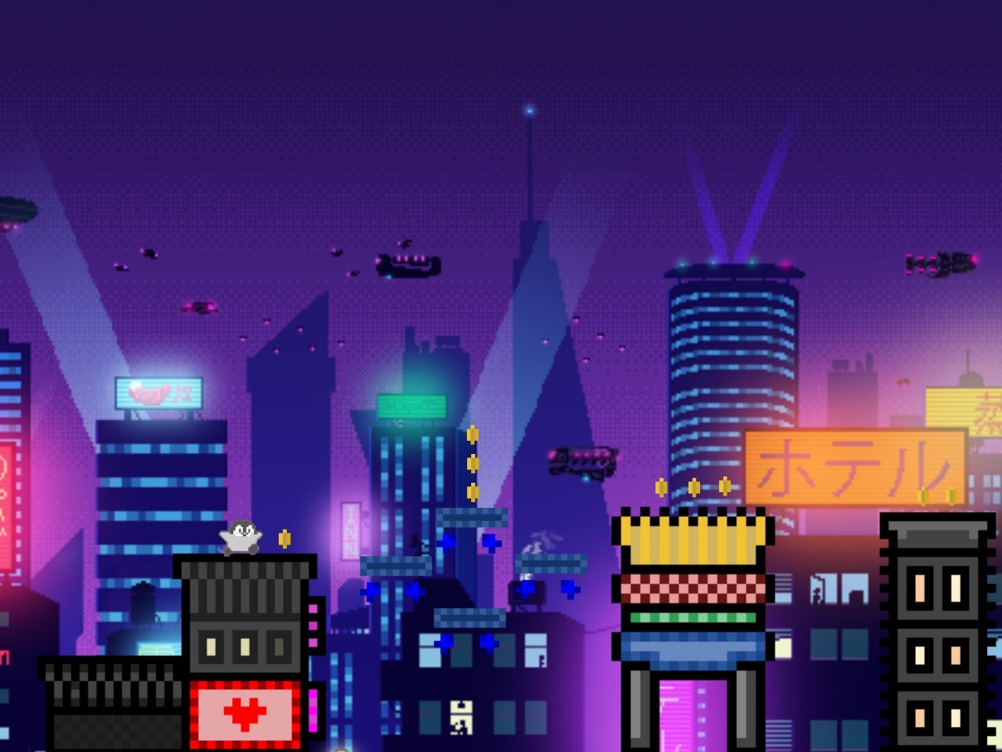

: Concept art for the tutorial stage of Cyber Haven.

Below is a rough concept of what each level will look like.

1. **Tutorial Level: A City Under the Stars:** Imagine the image above but with more detail. The city is having its last moment before destruction. Cyrus platforms over neon-buildings with windows and some very simple platforms. Nothing too complicated, just a standard tutorial level.
2. **Level 1: Shattered Neon Dreams:** Imagine the background city starting to fall apart, buildings are starting to fall, and the lights are less bright. Cyrus has to do more complex, but still simple, platforming over some buildings that are still *roughly* intact. A few cracks here and there but for the main part, the foreground buildings are still safe for Cyrus to jump on.
3. **Level 2: The City’s Final Stand:** Imagine the level to be more complex with fallen buildings, hole and cracks in the platforms, and so much more. This level has a much more complex difficulty then the others. It needs to be darker, as by now all the city lights have been shut off leading to the atmosphere of the level to be darker, and it’s slightly harder to see. This level will also introduce robots that hurt the player if they run into them.
4. **Final Level, Part 1: One Last Leap:** By far the longest level so far, imagine this level to be destroyed by now. The end of the world is here and Cyrus has to platform to safety to be able to be safe at last. This final challenge is a true test of the players skills and have some of the most complicated platforming by far. Many robots will be after Cyrus, and this level ends when he reaches the space station entrance at the end of the level.
5. **Final Level, Part 2: Safety Among the Stars:** This is the true final challenge. This is a final platforming which is inside a giant space station which will lead him to a rocket which will allow him to reach Mars. He must jump and fight his way to the rocket in order to win, dogging newly buffed robots. Once he makes it inside the rocket, the credits will play.

# Related Games

Cyber Haven is extremely like *New Super Mario Bros Wii*, which was a game released by Nintendo in 2009 for the Wii. The reason why we chose to take inspiration from this game was as many people agree it is one of the best 2D platformers released, and by far the best game in the *New Super Mario Bros.* Series. It has a 87 on meta-score and has many positive reviews, like:  
  
“New Super Mario Bros. Wii brings all of the classic fun from past Super Mario Bros. releases together in one amazing greatest hits-style gameplay experience and does so in a way that only Nintendo themselves can do. If you only buy one game for your Wii console for the rest of your life, make sure it's this one.”

-Nintendo Life

We took inspiration for Cyrus’ **Belly Slide** ability from this game as well. This is seen more in the *Mechanic Analysis* section in this document.

The game takes also many bits of inspiration from the story game *Stray* which was released in 2022 by BlueTwelve Studio on Steam, and was later brough to consoles during Christmas 2023. Our game takes a lot of inspiration from Stray due to its atmosphere and design, and slight inspiration of its level design. Many of the designs for the buildings and billboards take inspiration from the areas seen in Stray.

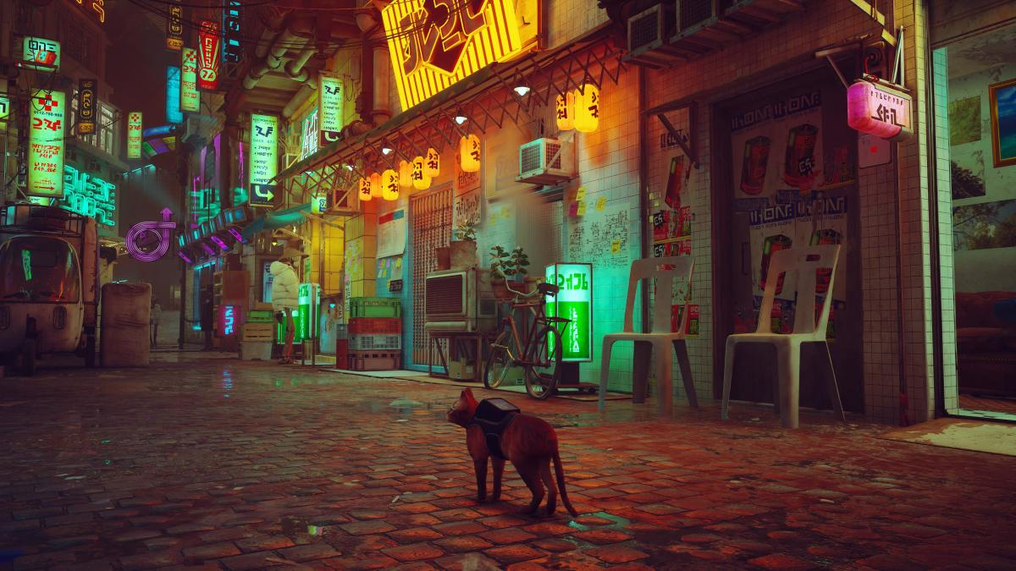

2: A photo of the Cyberpunk streets of Stray.

We also took inspiration from Stray with its unique use of a animal character. The game uses a cat as its main character and that gave us the unique idea to instead of making Cyrus a woman, making her a penguin.

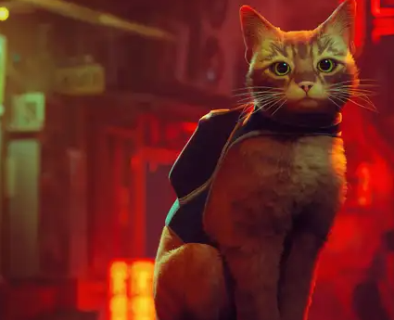

3: The main character in Stray, who is a cat named Murtaugh.

# Player Composites

"Kyle Witherson, 17, full-time student, single. Graduate of Villa-Maria. Plays video games once in a while with his friends. On weekends, he likes to explores the outdoors with his family. The main games he plays are mostly platformer games like Sonic and Donkey Kong. He watches tennis one day a week. Favorite movies are Tarzan and Jumanji. His favorite drink is Coke."

"Karen Hopkins, 35, principal at Hillcrest Academy, married and has 3 kids. Graduate of Concordia University. She wants to be trendy, learning about the video games her students are playing. She watches her kids play different platformer games like Hollow knight and Celeste. On weekends she watches her son play hockey and her daughter figure skate. Favorite movies are The Matrix and Swat. Her favorite drink is Root Beer."

"Aiden Joseph, 27, full-time student at McGill University, in a relationship. Graduate of Dawson. He’s currently studying to get his Bachelor of Computer Science (BCompSc). He enjoys making and playing games. He plays platformer games like Super Mario Bros. On weekends, he watches his favorite basketball team, The Dallas Mavericks, play. His favorite tv shows are The Flash and The Amazing Race. His favorite drink is Sprite"

# Game World

The game takes place in *Control City In The Year 2106.* This city is a bussing cyber punk city which is on the break of destruction due to years of ignored global warming.

# Game Characters

The main protagonist in *Cyber Haven* is the little penguin, Cyrus. Despite his cute and bubbly appearance, Cyrus is adventurous, always ending up in places he shouldn’t be. While out on a run, the weather suddenly becomes horrible. A tornado appears and sucks him up, bringing him on a rooftop in a place called Control City. Cyrus’ main goal is to escape the rooftops and travel to a Mars however, this is not going to be an easy task, as there are enemies trying to kill him. Will he be able to complete this goal?

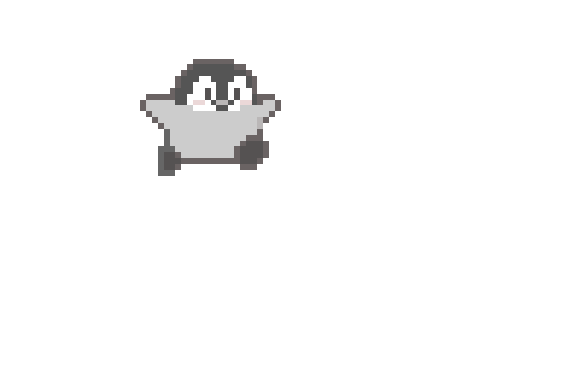

4: The sprite of Cyrus.

The main enemy in *Cyber Haven* is a robot. When you reach level 2, you will see this robot appear, trying to eliminate Cyrus. He becomes the main enemy until you reach Final Level (Part 2): *Safety Among The Stars*.

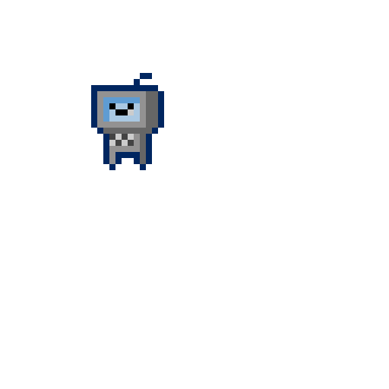

5: The enemy robot seen in certain levels of Cyber Haven.

Once you reach the final level in the game, the robots will become more powerful, becoming faster and there being more of them, making it more difficult for the player to win the game.

6: The enemy robot seen in the final level of Cyber Haven.

# Tags and Dialogue

Cyber Haven doesn’t have much dialogue, as we want to focus on a fuller platforming experience and worry less about the story of the game. Although, we still want a few things to be said to clarify what the game’s story is.

The tag *“StoryMessage000”* shows at the start of the game and shows a text that says:

“The end has begun. Control City is having a horrible tornado and in the middle of the chaos, a little penguin gets sucked up and blown away to the top of a building rooftop.”

The tag *“StoryMessage001”* shows after completing the tutorial level and shows a text that says:

“Buildings have begun to fall. You need to get to safety! Hurry!

The tag *“StoryMessage002”* shows after Level 1 and shows a text that says:

“You made it this far. Congratulations!” […pause…] “You need to get to the cosmodrome and launch to Mars in order to live safely. Be careful however, evil robots will try to stop you!”

The tag *“StoryMessage003”* shows once you finish Level 2 and shows a text that says:

“You reached the cosmodrome. Now get on a rocket ship! Good luck, Cyrus.” […pause…] Watch out for robots!”

The tag *“StoryMessage004”* shows once you finish The Final Level, Part 2 and shows a text that says:

“Cyrus presses some buttons, and before he knows it, steam comes out of the rockets engine, and he flies off to Mars, and lives happily ever after.” […pause…] “Thank you, for helping Cyrus find his way to safety.”

The tag *“JUMP”* refers to when Cyrus jumps.

The tag *“SLIDE”* is referring to when Cyrus uses his sliding ability

The tag *“HOVER”* refers to when Cyrus hovers.

# Controls

The control for Cyrus is simple, mainly as the game itself isn’t meant to be complicated. The controls are as follows:

* **W:** Allows Cyrus to jump.
* **W-HOLD:** Allows Cyrus to use his *Hover Glide* ability.
* **D:** Allows Cyrus to move right.
* **A:** Allows Cyrus to move left.
* **S:** Allows Cyrus to use his *Belly Slide* ability.
* **ESC:** Pauses the game.

# Art Direction:

The art direction used in Cyber Haven is a classic pixel art inspired styled. The backgrounds are created by artificial intelligence, and everything done in the foreground is made up of simple pixel art we created.

We create very simple pixel art to create the sprites seen in Cyber Haven. For example, seen below is a in progress photo of one of the buildings seen in the game.

6: An in-progress image of one of the buildings in the tutorial level.

The use of pixel represents the simplicity of the game, as platformer games are commonly seen as simple, especially Super Mario Bros. It also shows the perspective of old and new with the older retro pixel design with the futuristic cyber punk city.

Also, the difference between the pixel amount from Cyrus and everything is different as we wanted Cyrus to be different than everything else, as he is the main character of Cyber Haven.

# User Interface Storyboards

Here is some concept drawings for the graphical user interface for Cyber Haven.

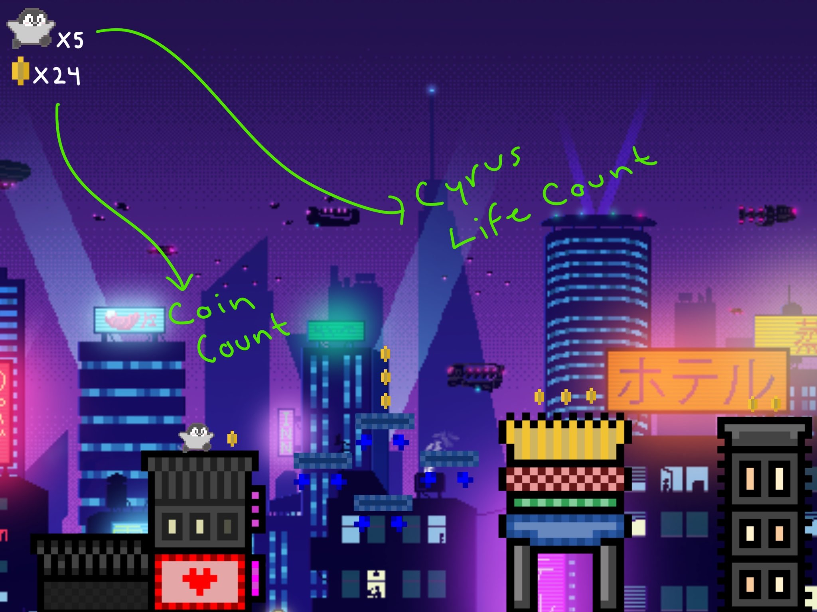

7: An early concept design of the UI for the life and coin count.

# Progression Graph

As *Cyber Haven* is a simple and short game, our progression graph is relatively small.   
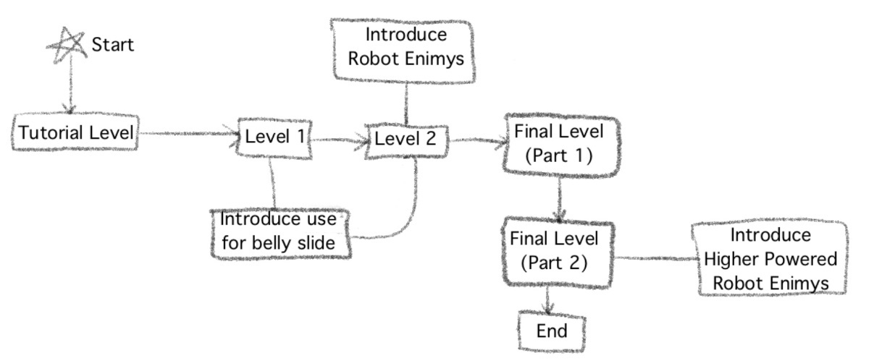

8: A look at the progression graph for Cyber Haven.

The game will start right away at **Tutorial Level: A City Under the Stars**, which will be a simple introduction to the mechanics of the game. It will then lead to **Level 1: Neon Shattered Dreams**, which will introduce the belly slide and show how it can be useful. Then, we will get to **Level 2: The City’s Final Stand** which is where we will introduce the enemy robots. Then, you go to **Final Level, Part 1: One Last Leap** where it’s just more complex platforming. After that, you go to **Final Level, Part 2: Safety Among the Stars** where you will be introduced at the higher-powered robot enemies. Finally, then you reach the end screen.

# Budget

Our game is for a school project at Vanier College. We have no budget, we’re poor. ☹

# Mechanic Analysis

As mentioned before, we took inspiration from New Super Mario Bros Wii. The game has a “Penguin Suit” which has a belly slide ability like the one used in Cyber Haven. In that game, it’s use to gain speed although in our game its used to go to secret areas that if Cyrus was standing up couldn’t access.

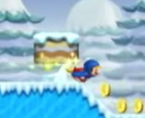

9: An image of the penguin suit from New Super Mario Bros. Wii.

# Level Design

The level design in Cyber Haven is fairy basic, and we don’t want the game to be too challenging, but at the same time we won’t make it incredibly as that takes the fun away.

# Schedule

The schedule for the game will be as follows:

|  |  |
| --- | --- |
| Complete the Game Design Document. | October 15th, 2024 |
| Create All Needed Pixel Art | October 22nd, 2024 |
| Code Cyrus’ + Robots Mechanics 🡪 Playable | November 7th, 2024 |
| Complete All Levels 🡪 Alpha | November 14th, 2024 |
| Alpha Testing | November 22nd, 2024 |
| 🡪Interim Checkpoint | November 27th, 2024 |
| 🡪Beta Version Complete | November 29th, 2024 |
| 🡪Golden Master Complete | December 1st, 2024 |

These dates are mainly estimates and are subject to change.

The roles for each person are as follows:

1. James Floyd: Level Concepts, GGD, Artwork
2. Nguyen Ngoc Mihn Trieu: Programming
3. Maro Shantelle, Sanjurjo: […]
4. Kyra Bryanna Durrant: […]

# Technology Plan

* For *Cyber Haven* we will be using the **Greenfoot Game Engine** created by Joe Godbout. Because of this, we are doing the code for the game in Java/Stride.
* For the *Game Proposal* and the *Game Design Document* we are using **Microsoft Word**.
* For the *artwork*, such as the *box art* and the *concept artwork*, we are using the iOS application **ProCreate**.
* For the *pixel artwork*, such as the *foreground objects*, and the *characters*, we are using the tool **DinoPixel**, which is a free to use website.
* For the *backgrounds*, we are using the AI-artwork application **DALL-E**. This may change in the future.

# Software Architecture

# Change Log